PRACTICAL GO FOUNDATION COURSE ARDAN LABS

**SUMÁRIO**

1 DAY 01 3

# DAY 01

The operator := means that you declare and assign a variable at same time.

## defer file.Close()

Is for close a file in a function scope, inside a function, this happens in a function level, always in a function if you use it outside a function you are doing wrong. If you have more than one defer in a function you have to call then in reverse order.

## cat http.log.txt| sha1sum

Works for catch a sha code in an file.

# DAY 02

## SLICES

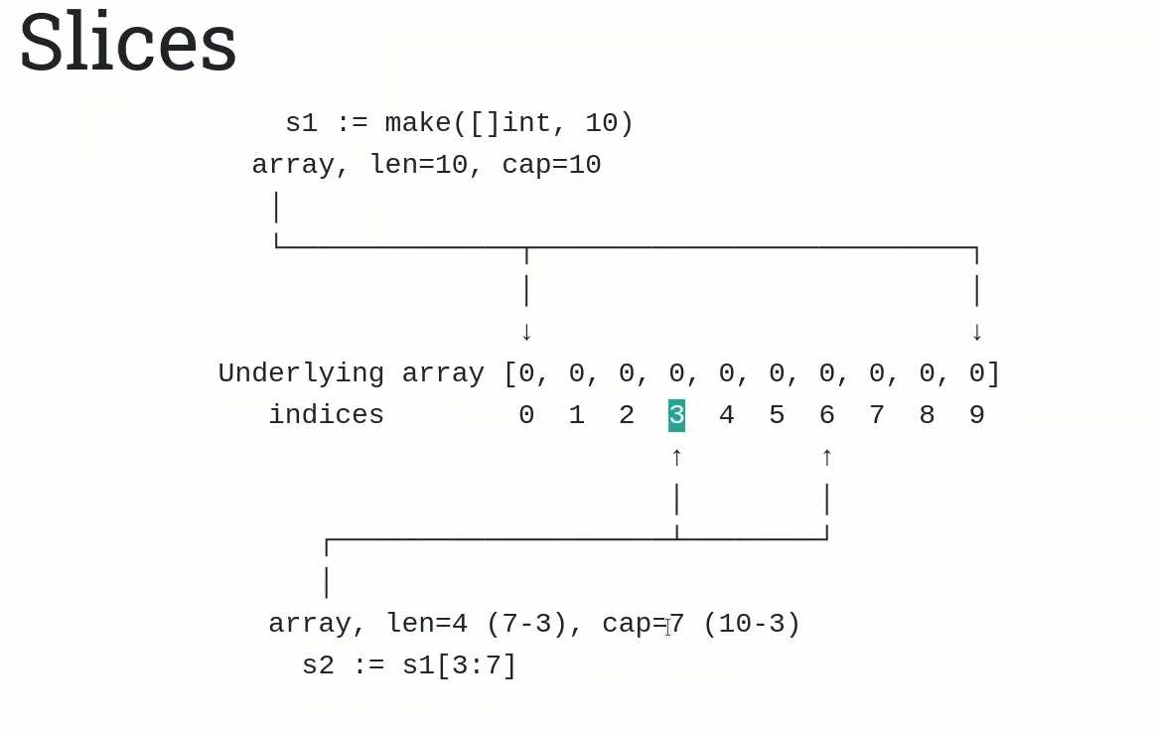

Searching in Google articles about “extending vs embedding” for clarification about that matter.